FSD for Add Case in SPA.

* User logs in.
* If user role = ‘SPA’ and user subrole in (‘CS’, ‘IC’), allow “ADD CASE” BUTTON in the Navigation. Else Disable the “ADD CASE” button.
* If the user click “ADD CASE”,
* Insert values in Temp table and create BP
* ~~Take the first case number with u_case_Status = ‘FREE’ and update u_case_status =’BOOKED’  
  If no such case number exists create a new case with U_case_status=’BOOKED’~~
* ~~If due to some issues and the case is not confirmed, change u_case_status from ‘BOOKED’ TO ‘FREE’.~~
* Set OCRD.OWNERIDNUM = user’s branch (ohem.branch)  
  E.g. “JJ”
* Set OCRD.CARDCODE = YYXXXXXXXX  
  E.g. “1500001298” where 15 is the year followed by running number with 8 digits.  
  Set OCRD.CARDNAME = “JJ/1500001298/SPA” where JJ is the branch code, followed by OCRD.CARDCODE and the application type.

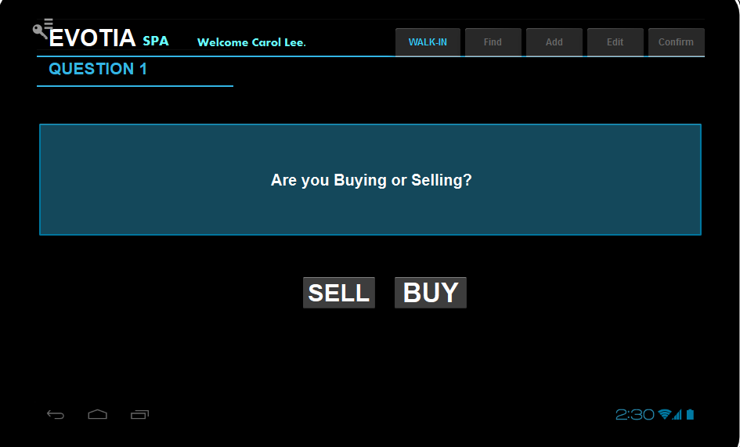

* If user click “SELL”,
  + Set OCRD. QryGroup3 =’Y’.
  + Set OCRD. U_VNDR_RP_FIRM =”Y’
  + Set OCRD. U_VNDR_RP_LWYR=”Y”
* If user click “BUY”,
  + Set OCRD. QryGroup4=’Y’.
  + Set OCRD.U_PURCH_RP_FIRM=”Y”
  + Set OCRD.U_PURCH_RP_LWYR=”Y”

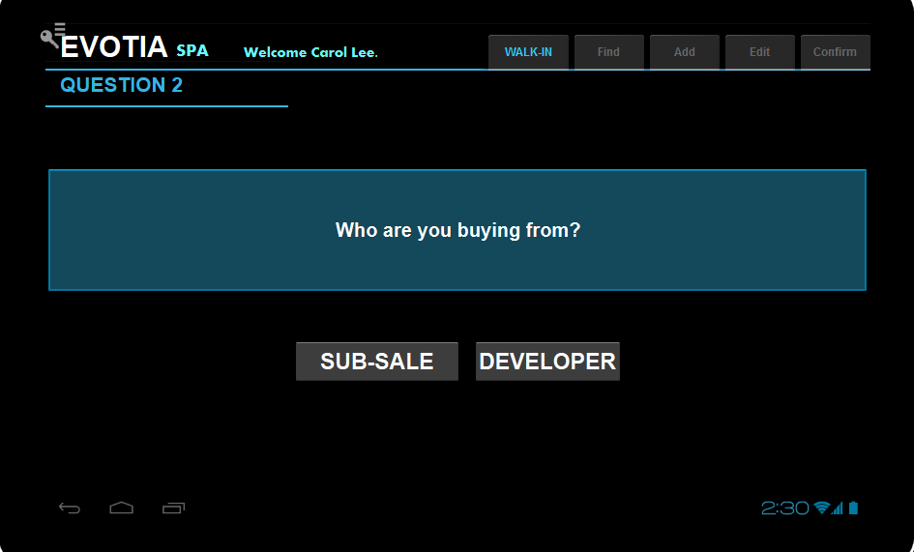

* If user click “SUB-SALE”,
  + Set OCRD. QryGroup6=’Y’.
* If user click “DEVELOPER”,
  + Set OCRD. QryGroup5=’Y’.

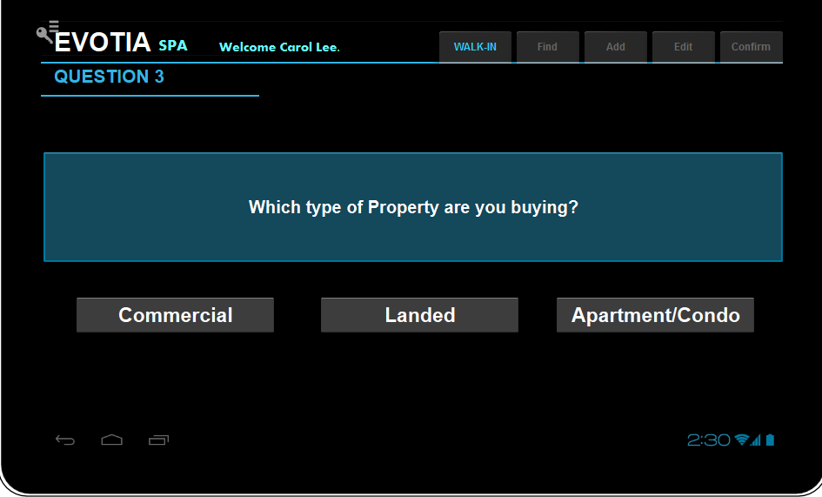

* If User Click Commercial,
  + Set OCRD. QryGroup7=’Y’.
* If User Click Landed,
  + Set OCRD. QryGroup8=’Y’.
* If User Click Apt/Condo,
  + Set OCRD. QryGroup9=’Y’.

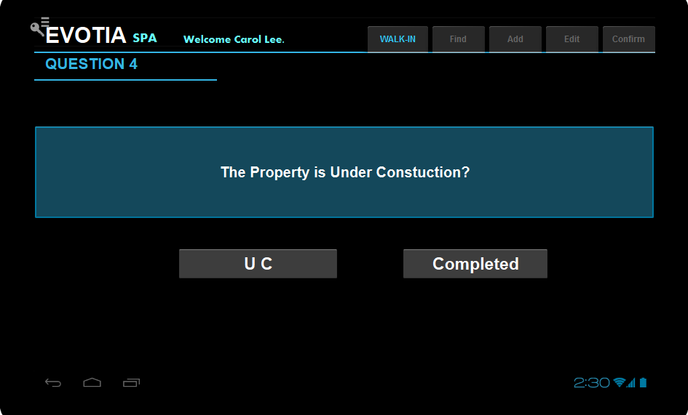

* If User Click UC,
  + Set OCRD. QryGroup10=’Y’.
* If User Click Completed,
  + 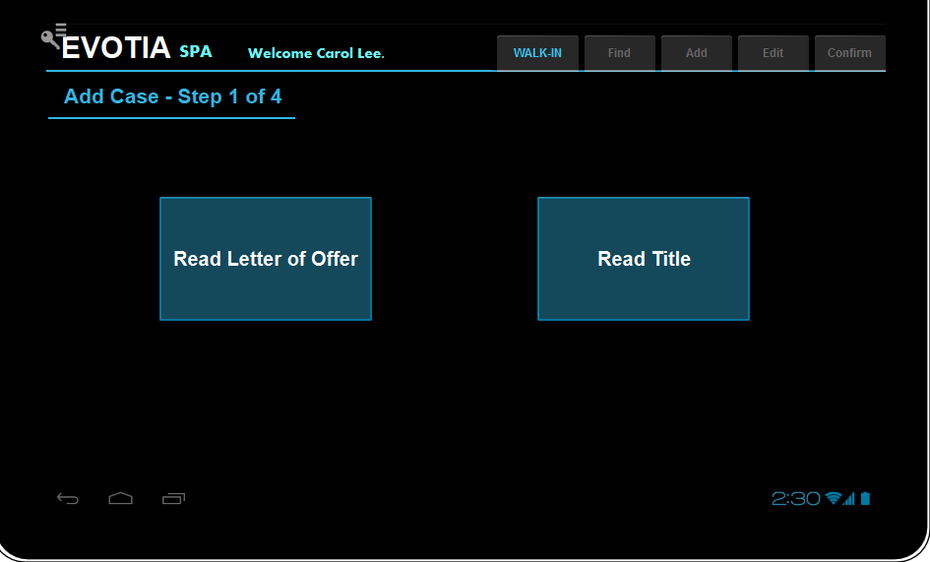Set OCRD. QryGroup11=’Y’.
* Remove Read Letter of Offer and Read Title buttons
* Include New button : **Choose Document to Read**
* If user click Choose Document to Read button, Pop Up a screen to let user choose from a list of options:   
  SELECT T0.[ItemCode], T0.[ItemName] FROM OITM T0 WHERE (T0.[ItemName] like '%Letter of Offer%' and not (T0.[U_RELATED_BANK] is null)) or (T0.[ItemName] like '%Title')  
  union   
  Select null, “Other Bank Letter of Offer”
* ~~One additional Option for “Other Bank Letter of Offer”.~~
* If user select from one of the item is the list, prompt user to select file from local folder.  
  Web service to transfer file to server and read the file with the selected item code.  
  Program to save the item code selected by user.
* If user chooses “Other Bank Letter of Offer”, go to next step.
* ~~If user chooses “Title”, prompt user to select file from local folder.  
  Web service to transfer file to server and read the file with the item code “100007”.~~

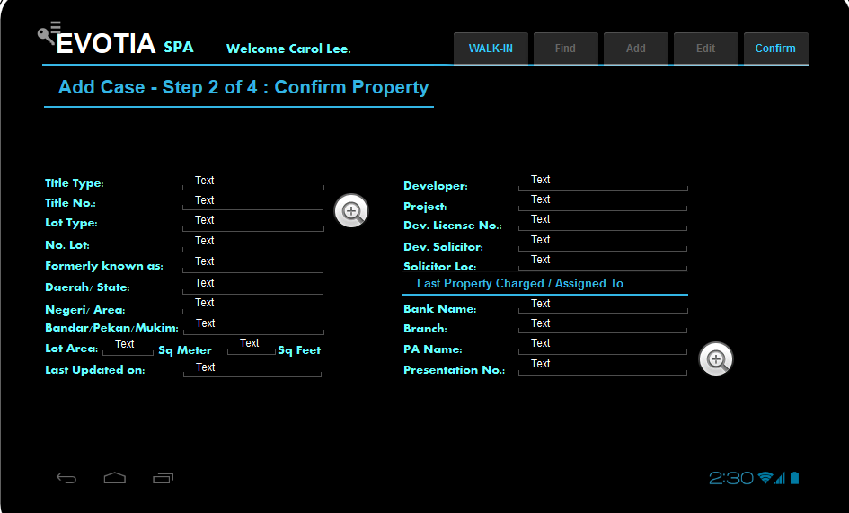

* Previous webservice update the scan results in selected fields.
* Users need to choose / update manually for fields not captured.
* Developer:   
  SELECT T0.[Code], T0.[U_NAME] FROM [dbo].[@AE_RELATEDPARTY] T0 WHERE T0.[U_DEVELOPER] ='Y'  
  Mandatory if user chooses clicked “DEVELOPER” earlier.
* Project:  
  select Prjcode, PrjName from oprj p inner join [@AE_RELATEDPARTY] c where p. [U_DEVELOPER] = c.code and p.active=’Y’ or p.prjcode in (‘I’, ‘NP’)  
  User to choose from the list. Mandatory.
* Solicitor:   
  SELECT T0.[Code], T0.[U_NAME] FROM [dbo].[@AE_RELATEDPARTY] T0 WHERE T0.[U_SOLICITOR] ='Y'  
  User to choose from the list.
* Bank:   
  SELECT T0.[Code], T0.[U_NAME] FROM [dbo].[@AE_RELATEDPARTY] T0 WHERE T0.[U_BANK] ='Y'  
  User to choose from the list.
* User clicks Confirm to save.  
  Program to check if title type, title no, lot type and lot no exists.   
  If exists, pull out the existing record with “List of Property”.
* Do not allow case to proceed if list of property exists.

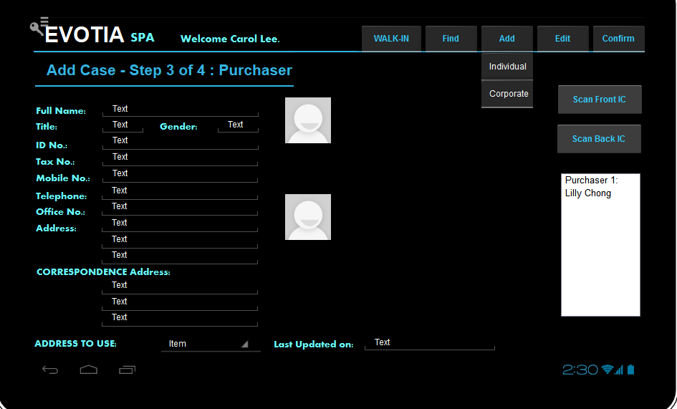

* ***User choose “Add Individual or Corporate”.
* If User choose “Corporate”:  
  SELECT T0.[Code], T0.[U_NAME] FROM [dbo].[@AE_RELATEDPARTY] T0 WHERE T0.[IDTYPE]=’corporate’  
  Scan IC buttons will be dimmed off.  
  User to choose from the list.
* If User choose “Individual”  
  User click read front IC.   
  Call up the read template for Front IC.  
  Transfer file to folder in server.  
  Update information from the scan results to case.
* User clicks read back IC.   
  Call up the read template for back IC.  
  Transfer file to folder in server.  
  Update information from the scan results to case.
* User updates details.

* User click confirm.
* Pop up screen to ask if user wants to add another Purchaser.
* If yes go back to ***.
* Allow to add up to 4 Purchasers.
* If no go back to next screen.
* This step will create @AE_RELATEDPARTY records with IDTYPE=’INDIVIDUAL’
* UPDATE OCRD.U_PURCH_RP_CODE1 TO OCRD. U_PURCH_RP_CODE4 with the respective records created.

Update OCRD.U_ PURCH_RP_ID1 TO OCRD.U_ PURCH_RP_ID4 with the [@AE_RELATEDPARTY.U_ IDNO_F1]

Update OCRD.U_ PURCH_RP_NAME1 TO OCRD.U_ PURCH_RP_NAME4 with the [@AE_RELATEDPARTY.U_NAME]

Update OCRD.U_ PURCH_RP_TAX1 TO OCRD.U_ PURCH_RP_TAX4 with the [@AE_RELATEDPARTY.U_ TAXNOFORMAT1]

Update OCRD.U_PURCH_CONTACT1 TO OCRD.U_PURCH_CONTACT4 with the [@AE_RELATEDPARTY.U_ CONTACT_MOBILE]

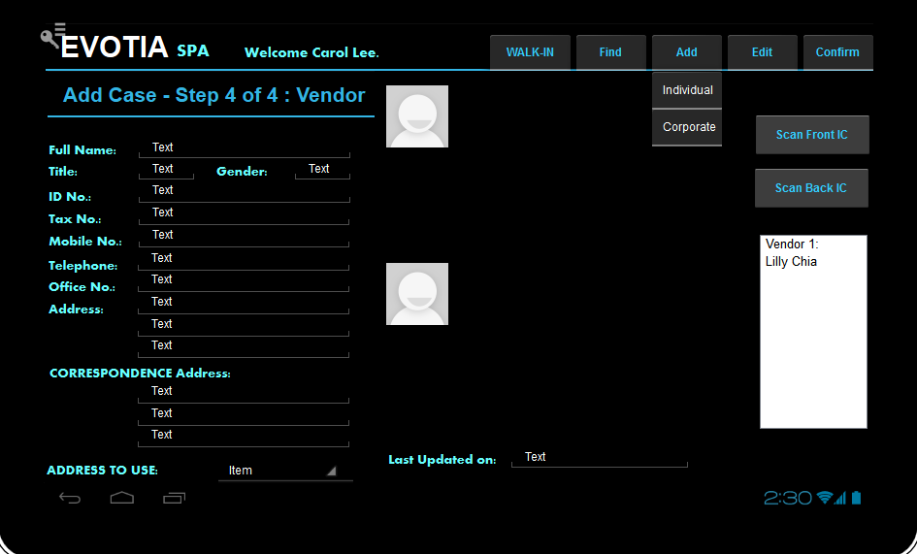

* Same as Purchaser, but UPDATE OCRD. U_VNDR_RP_CODE1 TO OCRD. U_VNDR_RP_CODE4 with the respective records created.
* Update OCRD.U_ VNDR _RP_ID1 TO OCRD.U_ VNDR _RP_ID4 with the   
  [@AE_RELATEDPARTY.U_ IDNO_F1]
* Update OCRD.U_ VNDR _RP_NAME1 TO OCRD.U_ VNDR _RP_NAME4 with the [@AE_RELATEDPARTY.U_NAME]
* Update OCRD.U_ VNDR _RP_TAX1 TO OCRD.U_ VNDR _RP_TAX4 with the [@AE_RELATEDPARTY.U_ TAXNOFORMAT1]
* Update OCRD.U_ VNDR _CONTACT1 TO OCRD.U_ VNDR _CONTACT4 with the [@AE_RELATEDPARTY.U_ CONTACT_MOBILE]
* Create case and save the scan files to the respective links.
* Duplicate the exact ocrd record, but append a “C” to the ocrd.cardcode.
* Set OCRD.CARDCODE = YY-XXXXXXXXC  
  E.g. “15-00001298C” where 15 is the year followed by running number with 8 digits.

Create a sales quotation under OCRD.CARDCODE = YY-XXXXXXXX  
with the items selected by stored procedure.

Exec getSPAProcessFlow

@currentSeq numeric

,@projectCode varchar(20)

, @buy varchar(1)

, @sell varchar(1)

,@subsale varchar(1)

,@developer varchar(1)

,@commercial varchar(1)

,@landed varchar(1)

,@apt varchar(1)

,@completed varchar(1)

,@underconstruction varchar(1)

for now use the following:

SELECT T0.[ItemCode], T0.[ItemName], T0.[U_INT_CASE_SEQ] as [INTNO], T1.TrnspName , t2.ItmsGrpNam, T0.U_DOCUMENT_BY, T0.u_start_status, T0.U_FAIL_CLOSE

FROM OITM T0

INNER JOIN OSHP T1 ON T0.[ShipType] = T1.[TrnspCode]

inner join oitb t2 on t0.ItmsGrpCod = t2.ItmsGrpCod

WHERE T0.[QryGroup3] ='Y' --[SPA - BUY]

and T0.[QryGroup5] ='Y' --[SPA - DEVELOPER SALES]

and T0.[QryGroup9] ='Y' --[PROPERTY - APT]

and T0.[QryGroup10] ='Y' --[PROPERTY - UNDER CONSTRUCTION]

ORDER BY T0.[U_INT_CASE_SEQ]